Calendar Module

Calendar Module 1
Summary 1
Installation 1
Configuration 3
Creating a new calendar 3
Content Structure 4
Security 4
Read-Only Mode: 4
Themes 5
User Guide 7

Summary
Calendar module helps you to arrange your personal schedule, track events and don’t miss important appointments. With the module you can easily create any event, either single or recurring; make it exposed to public or protected from unwelcome visitors; define personal list of calendars which are of interest to you. The module is completely dynamic. It means that you can even change your schedule directly from the web site, without necessity to have access to Content Editor.

Installation
To install the module you need:
- Install the module package (mandatory)
- Modify web.config (mandatory):

- Event handlers:

<!-- EVENT MAPS -->
<events>
…

<!-- ONSAVED handler -->
<event name="item:saved">
<handler type="Sitecore.Modules.EventCalendar.Logic.Handlers.EventItemHander, Sitecore.Modules.EventCalendar" method="OnItemSaved" />
</event>
…
<!-- ONSAVING handler -->
<event name="item:saving">
<handler type="Sitecore.Modules.EventCalendar.Logic.Handlers.EventItemHander, Sitecore.Modules.EventCalendar" method="OnItemSaving" />
</event>

….
<!—ONMOVED handler -->
<event name="item:moved">
<handler type="Sitecore.Modules.EventCalendar.Logic.Handlers.EventItemHander, Sitecore.Modules.EventCalendar" method="OnItemMoved" />
</event>
….
</events>

In total there should be 3 new entries in the <events> sections

B) <httpHandlers>
…
<add verb="*" path="*.asmx" type="Microsoft.Web.Services.ScriptHandlerFactory" validate="false"/>
…
</httpHandlers>

C) <configSections>
…
<sectionGroup name="microsoft.web" type="Microsoft.Web.Configuration.MicrosoftWebSectionGroup">
<section name="webServices" type="Microsoft.Web.Configuration.WebServicesSection" requirePermission="false" />
</sectionGroup>

</configSections>

D) <configuration>
….
<microsoft.web>
<webServices enableBrowserAccess="true" />
</microsoft.web>
.…
</configuration>

- Configure the module (optional since the module goes with sample data)

The module installs itself into:
- Master database:
  - /sitecore/calendars – sample data
  - /sitecore/system/modules/calendar
  - /sitecore/templates/calendar
- File system
  - /bin/ Sitecore.Modules.EventCalendar.dll – main binary file
  - /sitecore modules/shell/sitecore.calendar – module files

After you have installed / configured the module, you can go to the main calendar page to the module in action:
http://localhost/sitecore%20modules/shell/sitecore.calendar/controls/calendar.aspx

//
<configSections>
…
<sectionGroup name="microsoft.web" type="Microsoft.Web.Configuration.MicrosoftWebSectionGroup">
<section name="webServices" type="Microsoft.Web.Configuration.WebServicesSection" requirePermission="false">
</section>
</sectionGroup>
</configSections>
---------------------------------------------
<configuration>
…
<microsoft.web>
<webServices enableBrowserAccess="true">
</webServices>
</microsoft.web>
…
</configuration>
-------------------------------------
<httpHandlers>
…
<!-- Start of changes for Starter Kit: Atlas Support -->
<add verb="*" path="*.asmx" validate="false" type="System.Web.Script.Services.ScriptHandlerFactory, System.Web.Extensions, Version=1.0.61025.0, Culture=neutral, PublicKeyToken=31bf3856ad364e35"/>
<add verb="*" path="*_AppService.axd" validate="false" type="System.Web.Script.Services.ScriptHandlerFactory, System.Web.Extensions, Version=1.0.61025.0, Culture=neutral, PublicKeyToken=31bf3856ad364e35"/>
<add verb="GET,HEAD" path="ScriptResource.axd" type="System.Web.Handlers.ScriptResourceHandler, System.Web.Extensions, Version=1.0.61025.0, Culture=neutral, PublicKeyToken=31bf3856ad364e35" validate="false"/>
</httpHandlers>
//

Configuration
The module settings are stored in two places – in web.config and in Master database. In this section we will cover the setting from Master database. For web.config settings see Installation section.

The settings’ root node is /system/Modules/Calendar.

There are two nodes under /system/Modules/Calendar:
- Schedules – the module uses this node for storing schedules for recurring events. Normally you shouldn’t be concerned about the node, since the module uses it for internal use.

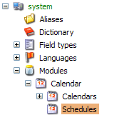

- Calendars – contains the module-wise settings such as
Default Dot Image – specifies a default icon for day cells (takes effect if Current Month Dot Image or/and Other Month Dot Image are/is empty );
Current Month Dot Image – specifies an icon for day cells of an active month;
Other Month Dot Image – specifies an icon for days cells of months adjacent to the active one;
Theme (see Themes section of this manual) – defines an active CSS theme;
Read-only – causes the module to work in Read-Only mode where a user cannot edit events from the web site;
Show Login Screen – if selected a user is redirected to a login page (goes with the module)

Creating a new calendar
You should create a new calendar under Calendars node.

The calendar should be created from “Calendar.Calendar” template:

Title – name of the calendar
Source – link to a content node storing events (see Content Structure section of this manual)
Selected – specifies if the calendar is selected in the Calendars List on the main module page (front-end) by default;
Text Color – specifies text color of an event;
Background Color – specifies background color of an event;
Event Dot Image – specifies an icon for an event;

Content Structure
The module creates events in Master database from “Calendar.Event” template.
The module uses stores events in predefined structure:
Calendar/Year/Month/Day/Event

Example:
For “Appointment with Dentist” event for the second of February, 2007 the structure would be:
Personal /2007/02/04/Appointment with Dentist (please see the picture below)

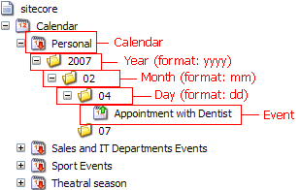

Please note that the module uses two digits for storing days and months, i.e. 2007/02/07 for the second of February, 2007 (not the 2007/2/7 or 2007/02/7, or 2007/2/07)

Security
The module creates and stores all events in master database. Hence the main security domain you should be concerned about is the internal security (Sitecore database). Whenever you try to perform any action on an, event the module validates a current user against Sitecore database.

Read-Only Mode:
By default you can add/remove/delete/modify events from the site front-end. It isn’t satisfactory for exposed to public audience Internet sites, where you only need to advise visitors about the coming up events. To achieve this you can set the module to Read-Only mode. The mode renders the calendar static, i.e. you can only see the events, but cannot not modify/add/remove/delete.

NOTE: you can achieve the same effect if you revoke Write permissions for a user (e.g. Anonymous)

Even if the module in read-only mode you still can work with events from within Content Editor. For instance you can add new event based on “Calendar.Event” template, modify Start Time and so on.

NOTE: If you work with the calendar content nodes (e.g. events, days, months, years, calendars) directly from within Content Editor (e.g. copy/move/modify events) you should disable event handlers (comment them out in web.config). But please remember to enable them when the module works in a normal mode (not Read-Only).

Themes

The module goes with a set of predefined themes:

Theme Name | Example
Grey | 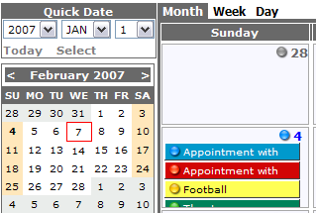
Red | 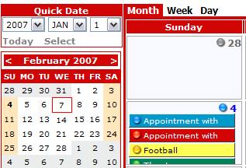
Green | 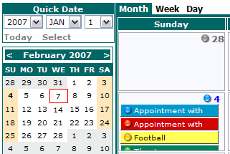
Blue | 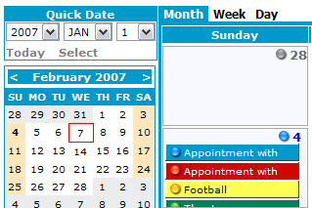
Black | 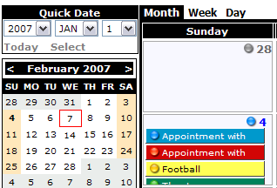

You can set the current theme on the /system/modules/calendars node:
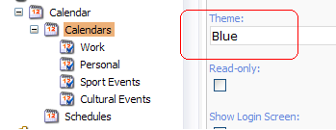

Please note that Theme name corresponds to physical subfolder containing Calendar.css file:
/sitecore modules/shell/sitecore.calendar/Themes/Blue (or Black, Grey, Red…)

If you want to set your custom color you can use Custom theme. What you need is just to set Theme to Custom, and replace main background color (e.g. #d20505) with a preferred one. You can find a custom theme file here:
/sitecore modules/shell/sitecore.calendar/Themes/Custom/Calendar.css

User Guide

The module interface is very intuitive. You can use your mouse for dragging and dynamically resizing events on the front-end. If you want to get a detailed view of an event, or delete/create/modify the event, you just need to click on a dot icon of the event (or a day cell if you want to create a new event)

There are three views:

1) Month view

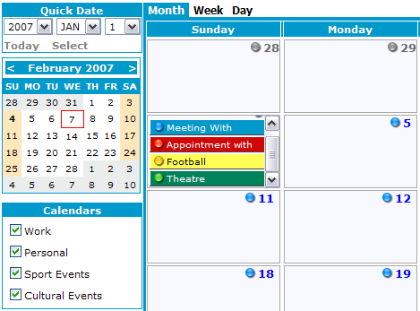

2) Week View:

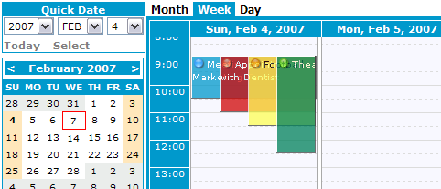

3) Day View
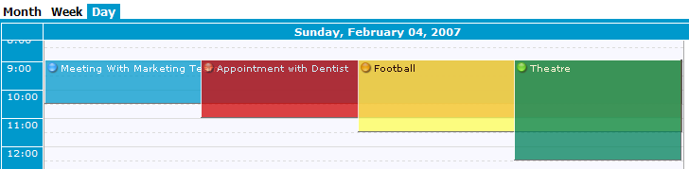

Creating a new event

There are three ways to create a new event

- In Month View:
  - click on the day dot to activate Event Wizard:

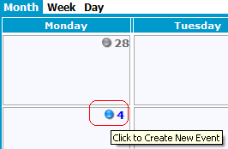

b) Specify event info and click Save button:

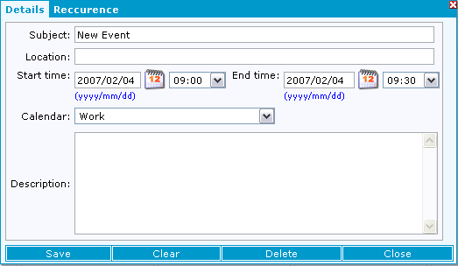

You can create two types of events:
- Single Event: an event occurs only once at a specified time on a specified date
- Recurrent Event: an event occurs periodically with defined frequency

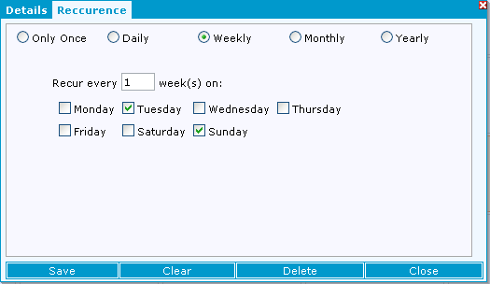

You can define 4 recurrence rules:
1) Daily:
Example: an event occurs on every tenth day from [1 January 2007] till [1 January 2010]

2) Weekly:
Example: an event occurs every 4 weeks on Tuesdays and Fridays from [1 January 2007] till [1 January 2010];

3) Monthly:
Example: an event occurs on last Friday of every second month from [1 January 2007] till [1 January 2010];

4) Yearly:
Example: an event occurs on 1st of January of every year from [1 January 2007] till [1 January 2010];

NOTE: you need to check that event’s End Date goes well with a defined Recurrence rule, i.e. your event might have a [StartDate:1/Jan/2007 – EndDate:1/Feb/2007] time spell, with “To occur on every 2nd year on January 7th” rule specified. Since the time lapse between “StartDate” and “EndDate” is only one month, the event will disappear.

All recurrent events go with “R” symbol which stands for “Recurrent”
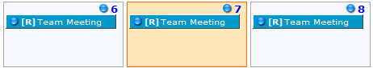

2) In Day / Week View:
a) click on the time grid of a required day to activate Event Toolbar

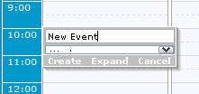
b) Click Create button, or Expand if you want to specify additional properties (different from Subject) of an event;

3) In Content Editor: you need to create an events from Calendar.Event master/template, and move it into an appropriate sub folder ( see “Content Structure» section)

NOTE: if you are in read-only mode you should disable the module event handlers (see “Read-Only Mode” section)

Modifying events
You can drag & drop events, dynamically resize them with you mouse.

To modify event details you need to activate Event Wizard by clicking on the event dot:
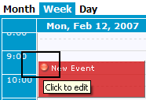

Deleting events
You can delete event by clicking Delete button on Event Wizard
For recurring events you can delete either a single event or recurrent series

Known Issues:
- The module is localized for English language only;

